**STEPS TO IMPORT EXCEL MACRO**

1. Create a new Excel sheet.
2. Click on Office Button > Excel Options. Select “Show Developer tab in the Ribbon”

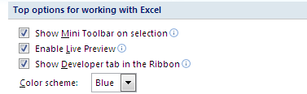

1. Now we should be able to see the following Tabs.

cid:image004.png@01CA2054.4753B3D0

1. Click on Developer > Macro Security > Macro Settings.  Choose “Enable all macros………….”.

**Check “Trust acess to the VBA project object model”.**

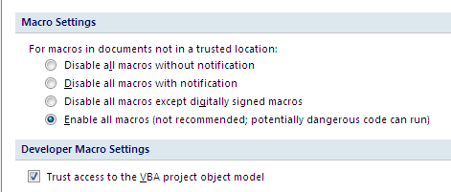

1. Close and open the excel sheet again for the changes to take effect.
2. Click on Developer > Macros. We will get the following pop-up

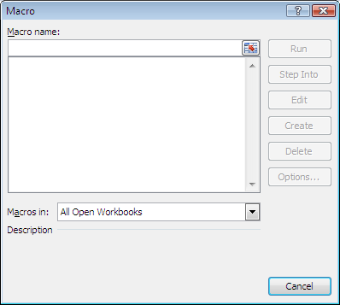

1. Enter a macro name, for e.g “MBFMacro” and click on “Create.”

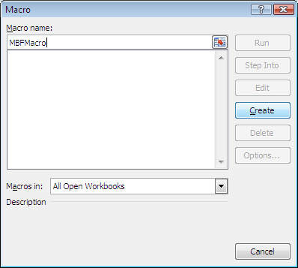

1. This should open up a VBA macro editor

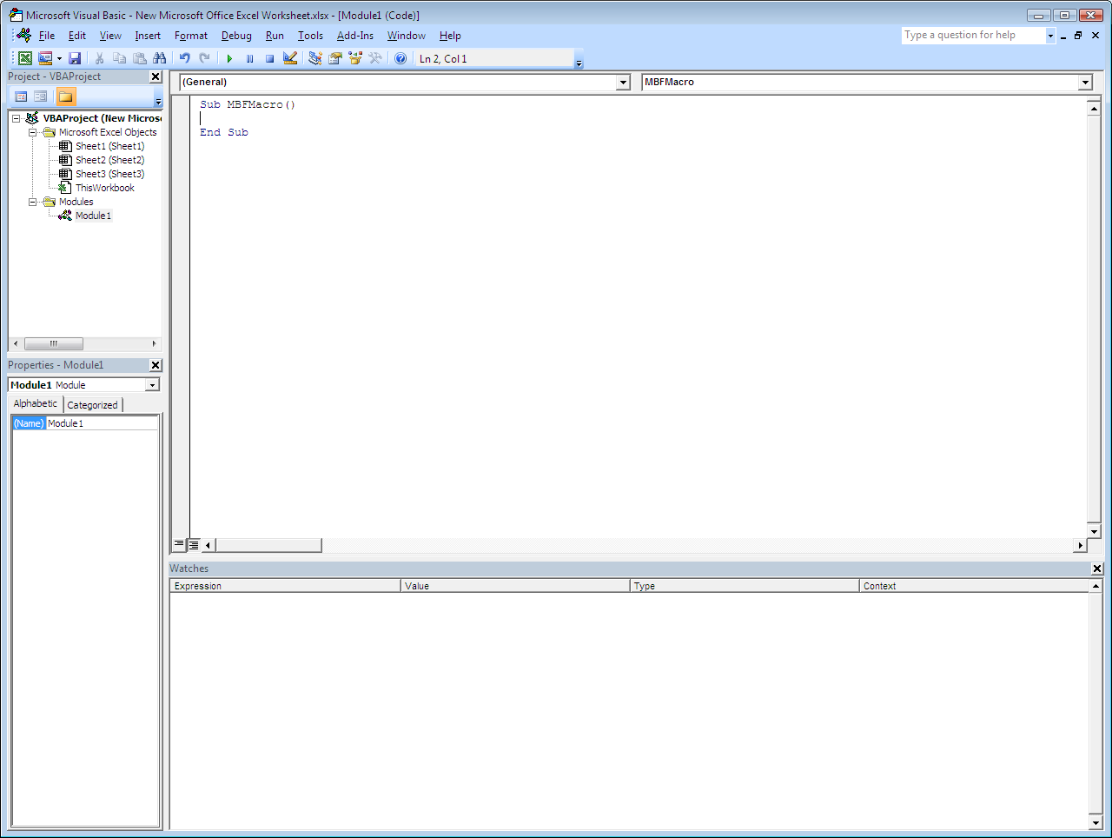

1. Right click on “VBAProject (New Microsoft Office Excel Worksheet.xls..). Click on “Import File…”

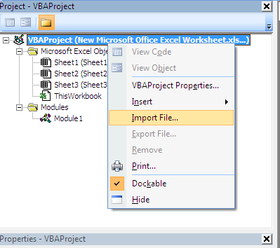

1. Clicking on “Import File…” will give the following Pop-up.

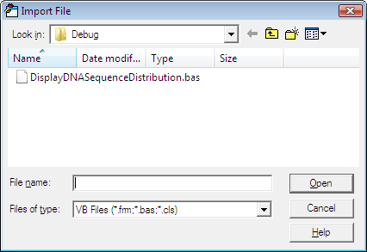

Navigate to DisplayDNASequenceDistribution.bas and click “Open”. The file will get imported.

1. A new module called “Module 11” will get added under VBAProject > Modules

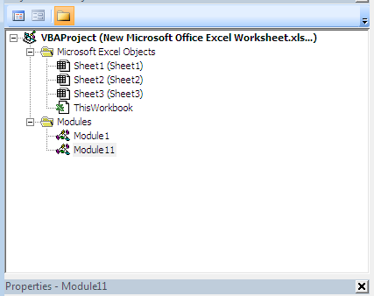

Double click on “Module 11” and we will be able to see the code for “DisplayChart()” macro.

1. Click on “Save” button. We will get the following pop-up:

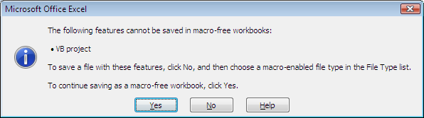

1. Click on “No”, we will get a file dialog. In the “Save as type” please choose “Excel Macro-Enabled Workbook (*.xlsm).

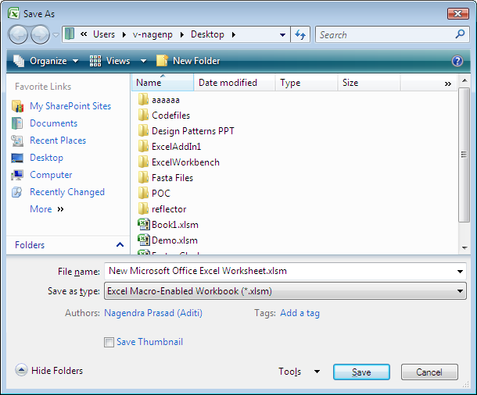

1. Save the file. This file will get saved with a “.xlsm” extension.
2. Ensure that the ExcelAddin is installed.Now we are ready to use the macro.